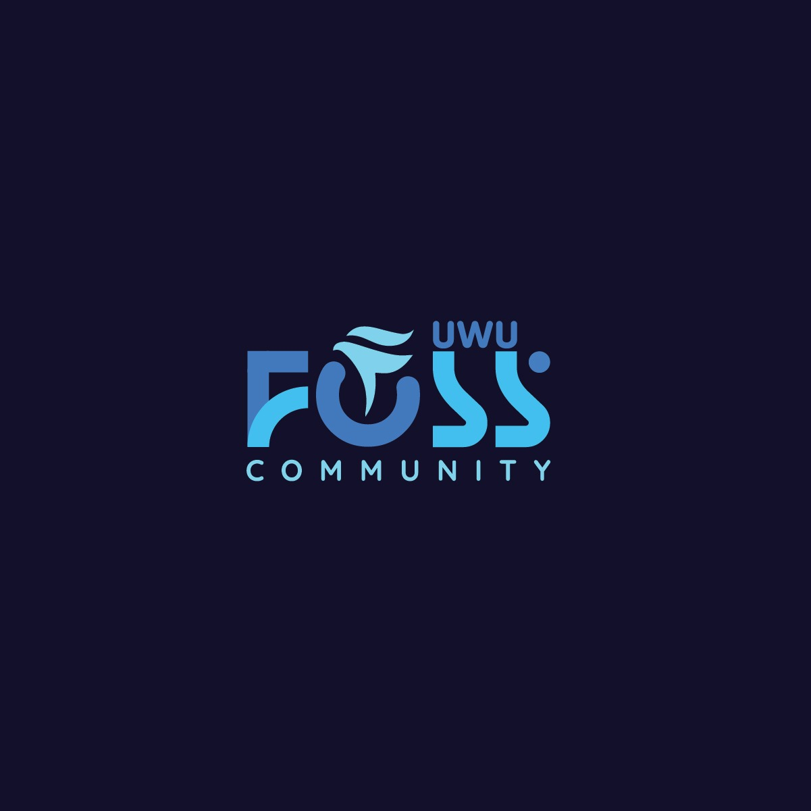

This logo represents the UWU FOSS Community — the Free and Open Source Software group at Uva Wellassa University (UWU). The design is not only visually modern and dynamic, but it also carries symbolic meaning that reflects the spirit and values of the community. Here's an interpretation based on the elements you've shared:

---

Logo Breakdown and Meaning

1. "FOSS" Lettering:

FOSS stands for Free and Open Source Software, representing openness, collaboration, and freedom in the tech world.

Each letter has a stylized and futuristic design, suggesting innovation, creativity, and technical skill.

2. Falcon Icon (Shaped into the “O”):

The falcon is a powerful symbol integrated cleverly into the "O" of FOSS.

In symbolism, a falcon represents:

Vision – Falcons have sharp eyesight, aligning with the community’s clear focus and foresight in tech trends.

Speed and Agility – Reflects how fast and adaptable the community is in learning, building, and contributing.

Leadership and Freedom – Falcons fly high and free, mirroring the FOSS philosophy of freedom to use, modify, and share.

Determination and Precision – Highlights the community’s dedication to excellence and detail in projects and contributions.

3. "UWU" above FOSS:

Clearly indicates the origin – Uva Wellassa University, rooting the community in a proud academic institution known for innovation and entrepreneurship.

4. "COMMUNITY" beneath:

Emphasizes the collective, inclusive, and collaborative nature of the group – it’s not just about coding but about building together.

---

Full Conceptual Meaning of the Logo:

> “The UWU FOSS Community, symbolized by a soaring falcon, represents the spirit of freedom, vision, and innovation rooted in the power of open-source collaboration. Just as the falcon flies high with clarity and speed, the community aims to rise above challenges, innovate boldly, and empower its members through shared knowledge and cutting-edge technology — all from the progressive grounds of Uva Wellassa University.”

Let me know if you'd like this turned into a formal mission/vision statement or a short version for a poster or website.